## 需要jar 和打开mybatis日志配置

log4j-1.2.17.jar

|  |
| --- |
| <dependency>  <groupId>log4j</groupId>  <artifactId>log4j</artifactId>  <version>1.2.17</version>  </dependency> |

mybatis-config.xml配置文件添加配置，打开日志主要是*logImpl*这个参数

|  |
| --- |
| <configuration>  <settings>  <!-- 全局映射器启用缓存 -->  <setting name=*"cacheEnabled"* value=*"true"*/>  <!-- 查询时，关闭关联对象即时加载以提高性能 -->  <setting name=*"lazyLoadingEnabled"* value=*"true"*/>  <!-- 设置关联对象加载的形态，此处为按需加载字段(加载字段由SQL指 定)，不会加载关联表的所有字段，以提高性能 -->  <setting name=*"aggressiveLazyLoading"* value=*"false"*/>  <!-- 日志实现方式。SLF4J、LOG4J2、LOG4J、STDOUT_LOGGING -->  <setting name=*"logImpl"* value=*"****LOG4J****"*/>  </settings>  </configuration> |

## 配置log4j.properties

|  |
| --- |
| ### set log levels ###  log4j.rootLogger = DEBUG , C , D , E  log4j.logger.org.springframework = OFF  ### console ###  log4j.appender.C = org.apache.log4j.ConsoleAppender  log4j.appender.C.Target = System.out  log4j.appender.C.layout = org.apache.log4j.PatternLayout  #log4j.appender.Console.layout.ConversionPattern=[%c]%m%n  log4j.appender.C.layout.ConversionPattern = [ssm_init][%p] [%-d{yyyy-MM-dd HH:mm:ss}] %C.%M(%L) | %m%n  ### log file ###  log4j.appender.D = org.apache.log4j.DailyRollingFileAppender  log4j.appender.D.File = logs/ssm_init.log  log4j.appender.D.Append = true  log4j.appender.D.Threshold = INFO  #log4j.appender.File.MaxFileSize=10MB  log4j.appender.D.layout = org.apache.log4j.PatternLayout  log4j.appender.D.layout.ConversionPattern = [ssm_init][%p] [%-d{yyyy-MM-dd HH:mm:ss}] %C.%M(%L) | %m%n  ### exception ###  log4j.appender.E = org.apache.log4j.DailyRollingFileAppender  log4j.appender.E.File = logs/ssm_init_error.log  log4j.appender.E.Append = true  log4j.appender.E.Threshold = ERROR  log4j.appender.E.layout = org.apache.log4j.PatternLayout  log4j.appender.E.layout.ConversionPattern = [ssm_init][%p] [%-d{yyyy-MM-dd HH:mm:ss}] %C.%M(%L) | %m%n |

## 配置web.xml

|  |
| --- |
| <listener> <listener-class>org.springframework.web.util.Log4jConfigListener</listener-class>  </listener> |

注意：

1. 这个监听器需要在ContextLoaderListener 之前配置
2. 如果log4j.properties文件不在根目录下，需要配置以下截图的

log4jConfigLocation参数

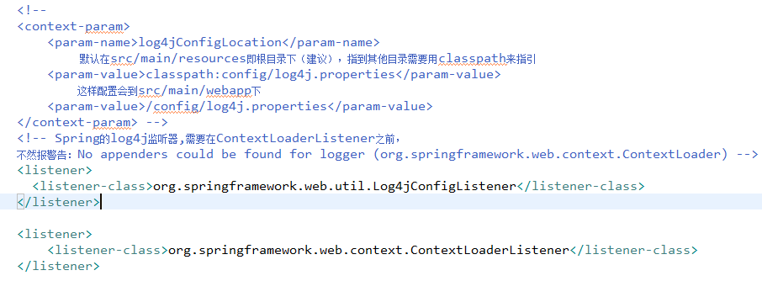

附件（资料）

Log4J日志配置详解 http://www.cnblogs.com/ITtangtang/p/3926665.html